CRAFT: GOSPEL MEGAPHONE

Here is a simple craft, with a fun way to practice the memory verse. You will need:
- colorful paper cups
- pipe cleaners
- a razor blade
- scripture print out
Galatians 6:9: We must not become tired of doing things for God. We will receive our harvest of eternal life at the right time – Don’t give up!
- scissors
- glue
- stickers
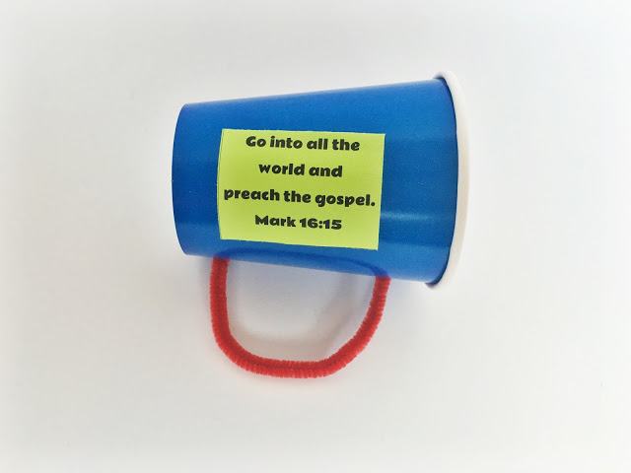
To prepare, use the razor blade to cut out the bottoms of the cups. Print, and cut out the scripture tags. Use the razor blade or other sharp object to poke holes in the cup, and cut the pipe cleaners in half.
Help your child/children assemble their megaphones. Insert the ends of the pipe cleaners into the holes you made, and bend the ends inside the cup. Glue the scripture tags to the megaphones, and provide stickers to decorate. Practice saying the memory verse using their megaphones.

