Surprise KIDS
Apr. 12, 2020 – Easter Sunday

MUSIC –  Song #1: Jesus is Alive, It’s a Happy Day!  https://youtu.be/FzxN0D3voo0?list=PLh_ZCcaNyX7f4BwV4-n7pWv-5r73jOM5M  Song #2: Jesus, you’re my SuperHero!  https://youtu.be/1FY4C930M2Y  OBJECT LESSON/BIBLE STORY – RESURRECTION SUNDAY!  Please watch our video that is loaded onto the Surprise Church website, under Families, Surprise Kids link. Miss Amanda is sharing about our Lord’s resurrection, using Resurrection Eggs. Follow along with the handout entitled, Resurrection Eggs.  CRAFT: Easter Salt Dough Crosses  2 Cups Flour  1/2 Cup Salt  2/3 Cup Water  2 Large Popsicle Sticks  Paper Plates-to lay your cross on when making it  Objects to stick in dough (seashells, jelly beans, buttons, feathers, glitter, jewels, stones, etc.)  Add 2 cups of flour to a bowl, add ½ cup of salt. Add your 2/3 Cup of water and mix it up real good. This will turn into dough.  This recipe will make a ball of dough. You will need 2 large popsicle sticks to make your cross.  You will get about 6 crosses out of this dough recipe. Make 2 round balls per cross.  Cover both popsicle sticks with the two dough balls. Put dough thick on the sticks, otherwise objects will not stick down in the dough. You don't have to cover the back if you don't want to.  Once you have covered both popsicle sticks with dough, lay one of the popsicle sticks on top of the other one to make a cross shape. Now you can press some objects into the dough. You can use Jelly Beans, Seashells, Wood Chips, Rocks, Glitter, Feathers, Buttons, Jewels, etc. After you decorate, allow the cross to dry for 24 hours.  ACTIVITY #1: String Easter Eggs  Supplies for String Easter Eggs  - Balloons – Some sources say to use water balloons, but those are harder to blow up. I’ve had just as much luck with regular balloons -small balloons work best for small eggs, but if you want to make a large Easter egg, then blow up a large balloon.  - Embroidery thread OR yarn  - White glue  - Wax Paper– to protect work area and to dry balloons on  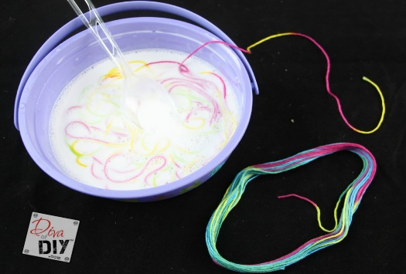  Instructions for String Easter Eggs  Step 1) In a large bowl, mix the glue with a small amount of water to thin out the glue. If you are going to make quite a few of them dump the entire bottle of glue into the bowl and thin with water. As you add the water to the glue stir until it’s mixed well.  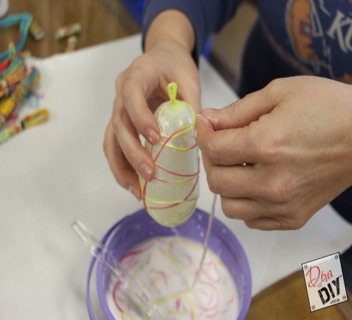  Step 2) Place your string in the glue mixture and stir to completely cover the string in glue.  Step 3) Begin blowing the balloons up. Make sure you blow up as many as you plan to do because your hands will soon be covered in glue.  Step 4) Wrap your string around the balloon. There really is no right or wrong way to do this, so just go for it!  Step 5) Let the string/glue dry laying them on the waxed paper, OR you can hang the eggs using a clothes pin and attaching to a hangar. This can take several hours or set overnight. Once the string is completely dry and harden you can use a sewing needle to pop the balloon.  Step 6) Use a needle to scrape off dried excess glue if needed.  ACTIVITY #2: A MUST SEE VIDEO -YOUR CHILD WILL LOVE IT!  A VERY SPECIAL EASTER - Crayon drawings animate real-life responses from children as they talk about Easter. Their unfiltered and heartfelt responses bring humor and depth to the subject. Only a child could mix the silly and the sacred to so powerfully illustrate what makes the story of Jesus and how we celebrate it so special. (STEELEHOUSEMEDIA)  https://youtu.be/zY2NH8Wpoog  ACTIVITY #3: Give a Gift Basket  Teach kids to perform a random act of kindness this Easter and put together a gift basket for an elderly relative or neighbor. Get creative with the contents to make this a more fun and meaningful activity. For example, have the kids fill plastic Easter eggs with nice notes that say things like, "You're egg-cellent!" and "Sweetest neighbor ever." Drop off the basket on their doorstep (remember social distancing!)  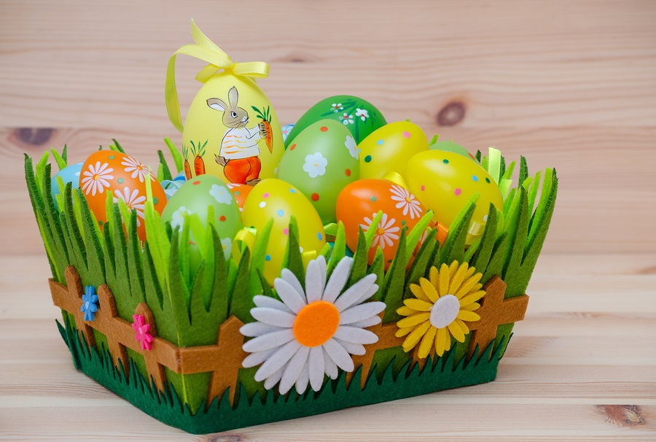 | BIBLE STORY  Above All  Crucified and Risen  John 18:12–20:23  (Supporting: John 16, Matthew 26)  MEMORY VERSE  “For God so loved the world, that He gave His only son, that whoever believes in Him, will not perish but have everlasting life.” John 3:16  LIFE APP  Humility—Putting others first by giving up what you think you deserve  BOTTOM LINE  Jesus put us first.  BASIC TRUTH  I can trust God no matter what.

